**Champions Glen HOA Annual Meeting Agenda**

**Thursday October 17th, 2024, at 7pm**

**Champions Forest Baptist Church, Room TBD**

Alan Kaniss called the meeting to order. A quorum was established. Board members in attendance were Alan Kaniss, President, Laurell Hayes, Secretary, and Paul Gross, Treasurer. In addition, the following committee members were present – Tim Timmerman, Architectural Committee, Carolyn Rogers, Landscape Committee, Elaine LeGrand, webmaster, and Deany Meinke. In addition, the following residents attended.

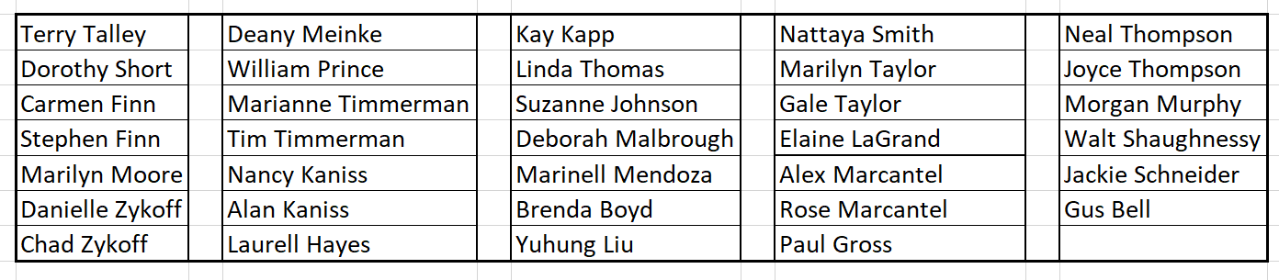

**Election of Board Members**

Alan indicated that the only business allowed at a Homeowners Annual meeting is the election of the Board of Directors. He indicated that nominations from the floor are welcomed, and that the new 2025 Board Members would have a standardized term of two years. The current Board is made up of Alan Kaniss-President, Paul Gross-Treasurer and Laurell Hayes-Secretary. Their terms expired on December 31, 2024. Paul and Alan are willing to continue in their current roles while Laurell is planning to submit her resignation. Alan asked for nominations from the floor for any of the three positions and no nominations were forthcoming. By rule, in an uncontested election no vote is required and both Paul and Alan will continue in their respective positions through December 31, 2026.

**Constable Program Withdrawal Discussion** **Con ~ Alan Kaniss | Pro ~ Carolyn Rogers**

Alan presented numerous reasons why our Constable’s program should be terminated. He mentioned we have a single entrance, very good streetlights, well-lit security lights on numerous homes, and few cars are parked in driveways and those are locked. It is not a target rich environment as such. He indicated that Champions Bend does not have a Constable program and gets extremely quick service when an incident does occur. They require each home to have a security system of some sorts even if it’s simply a “ring” doorbell. He pointed out that there is no evidence that the program deters crime in any way but rather is reactive when something occurs. He explained that the current system provides 3 eight-hour shifts of which we are entitled to 70% of the Constables time. Champions Glen makes up 4.6% of the

contract with Cypress Forest PUD. That equates to about 45 minutes per day and no one believes we have a constable in our neighborhood for that amount of time. He suggests that a home security system is the best deterrent to crime.

Carolyn Rogers presented a passionate defense of the current program. She indicated the initial program was established 16-years ago when she was the HOA President. CG was having crime in the subdivision and in a 6-month timeframe four incidents occurred with one home broken into with a safe taken, three cars were burglarized. CG is not a gated community and crime in our surrounding area had gone up significantly. CG had a rental home with many complaints and issues at all times of the day/night with a lot of people visiting that did not live at the rental home. After several unsuccessful attempts to obtain security through all resources in this area, I was able to connect us with the neighboring Constable program. We share this with other neighboring areas and however good or bad we feel it to be, we have had No Crime in Champions Glen since it was implemented. Another thing for consideration is the fact that if the constable program is discontinued, the signage indicating we have this protection will be removed. Lastly, home values are affected as buyers wish to purchase homes in a safe area and that means security of some sort is a welcomed asset. As homeowners we want to keep our values high and our neighborhood desirable.

Following the discussion and numerous comments from the homeowners Alan indicated that based on approximately 30% of the homeowners in attendance, he could deduce that the remaining 70% of our homeowners did not have any strong opinions on how the neighborhood was operating. He indicated that such a contentious issue should require a vote of the entire neighborhood and if so warranted, ballots would be delivered to each home and the votes would be counted in private, not in public, which might cause some residents to be hesitant to vote in a certain way. The current Constable program will continue, and the Treasurer will pay the invoice for 2025.

**Architectural Control Report**: **Tim Timmerman**

We have a new Architectural & Maintenance Policy posted on the website which has subtitles making it easier to look up items needed. In 2024 we had requests for 3 new roofs, 7 houses to be painted, 2 tree removals, and 3 generators were installed. Regarding new fence replacement requests, unless the fence in question is seen from the street and the replacement is the same as the previous fence, there is no need for approval. Otherwise, as a courtesy please submit a request. If there are any questions when completing the request form, please give Tim a call.

**Landscaping** **Carolyn Rogers**

Last year’s budget required removing the old holly bushes along the North & South Wall along Champions Forest Drive. Our Crape Myrtles were cleaned up and trimmed so all looked even in height. There was mulch and fertilizer added to all the landscaping.

Holiday lighting of the tree in the median will have 35-lights hanging from the top of the branches. The North & South wing walls will have new lighting this season. We had to increase the holiday budget this year due to the old decorations needing to be replaced. So be on the lookout for the holiday decorations to be in place a week before Thanksgiving as well as the fall flowers.

**Maintenance Report:** **Mubeen Muhammad**

In 2024 we spent $13,808 of our budgeted funds for street repairs on two sections of streets. Due to the high costs of other projects, we went out for additional bids and have deferred those areas of concern until 2025. Glen Allen flooded twice in 2024. We approached different several different contractors for estimates on adding additional curb drains to the NE corner of Glen Allen and Glen Canon. As evidenced by the increased amount of money being set aside in the 2025 budget, flood prevention is the number one concern of our Maintenance Committee going forward. The committee is made up of Ray Hahn, Guy Bell, Alan Kaniss and Mubeen Muhammed to develop a multi-year approach to street repairs. A detailed report will be posted on the website

**Treasurer’s Report**: **Paul Gross**

Paul reported that we have $90,000 in a Reserve Account in which the principal is being invested in 90-day Treasury bills. The interest from the T-bills is transferred into our general operating account. Paul pointed out that we are carrying forward approximately $30,000 from 2024 to 2025 with the majority coming from our street and wall maintenance budget and our legal line item. Our 2025 budget shows that we are planning to address the flooding issues on Glen Allen with the bulk of those funds. The trash contract has another year remaining and we don’t expect a major increase in our Constable program. He indicated that most of our bills are on automatic pay, and we are current on all accounts.

2025 Maintenance Fee will continue at the same rate of $770.00.

**New Business** **Alan Kaniss**

New Block Captains were introduced as follows:

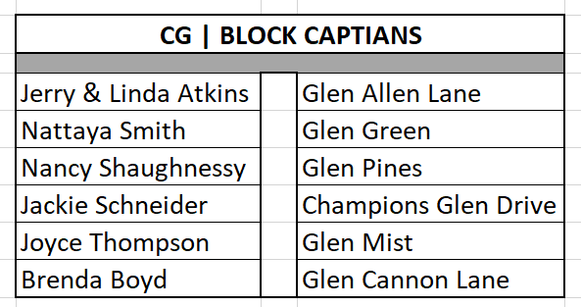

At a special meeting of the Board to be held before the end of 2024 the Board will consider and vote on adopting our Amended and Restated Bylaws, our new Leasing & Occupancy Policy and our Enforcement and Fine Policy. All the proposed policies have been Posted on our neighborhood website.

**Quarterly scheduled HOA Board meetings have been scheduled as follows:**

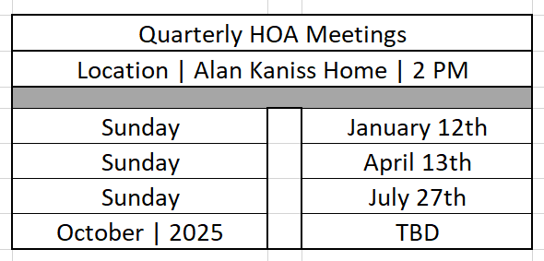

**Adjournment:**

The meeting was adjourned at 8:15pm

